Excel Assignment - 9

1. What are the different margins options and do we adjust the margins of the excel worksheet?

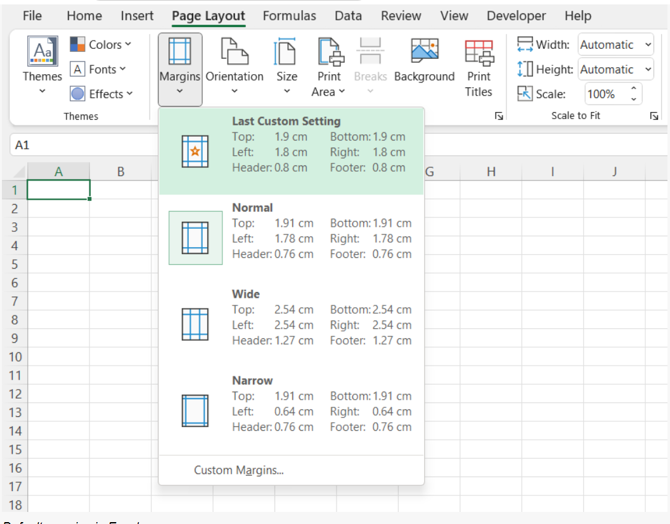

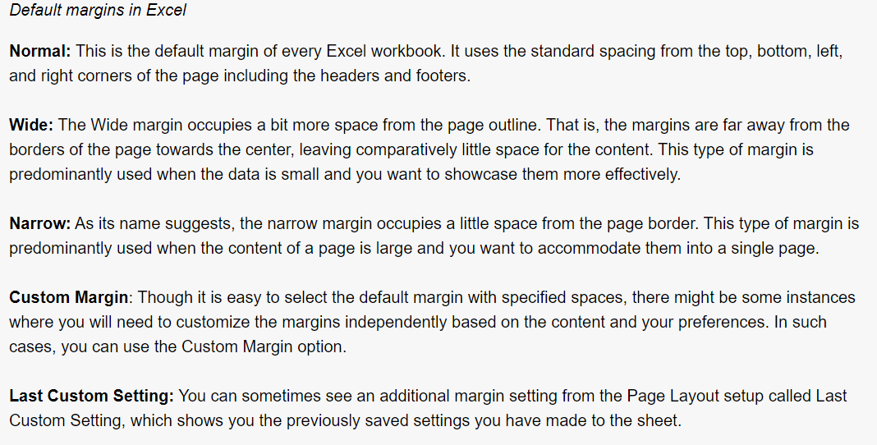

1. Set a background for your table created.

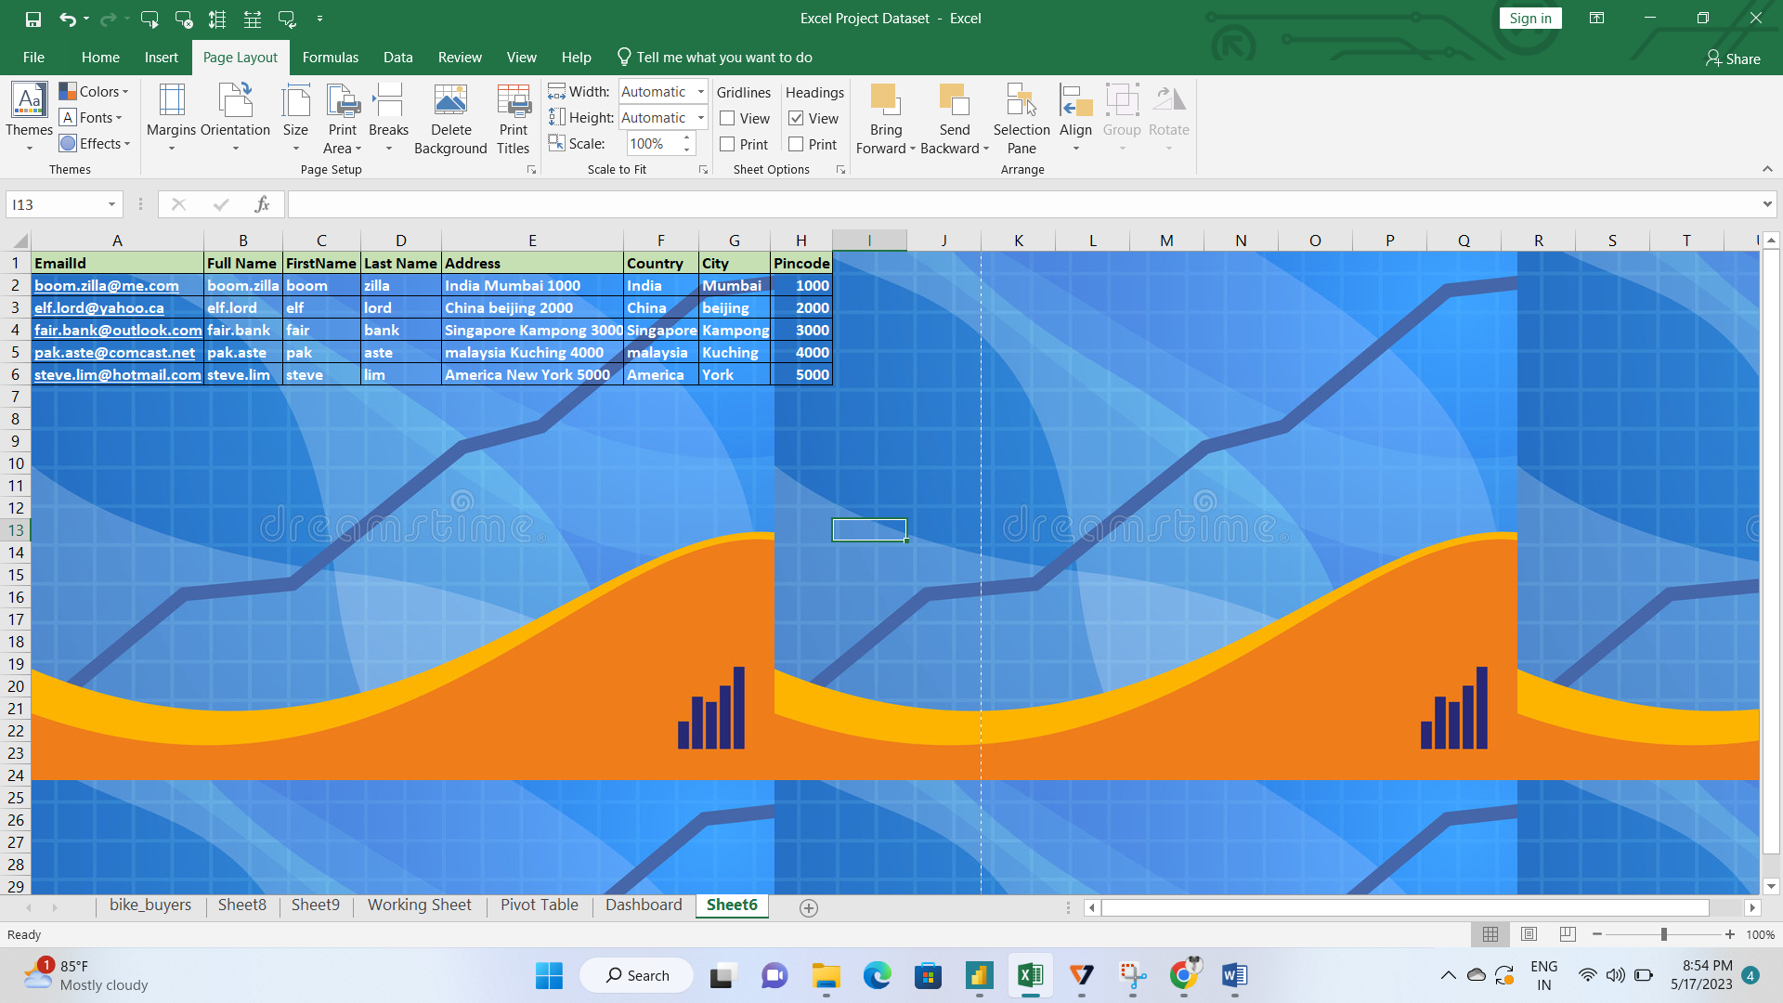

3. What is freeze panes and why do we use freeze panes? Give examples.

**To freeze rows:**

1. Select the row below the row(s) you want to freeze. In our example, we want to freeze rows 1 and 2, so we'll select row 3.
2. On the View tab, select the Freeze Panes command, then choose Freeze Panes from the drop-down menu.
3. The rows will be frozen in place, as indicated by the gray line

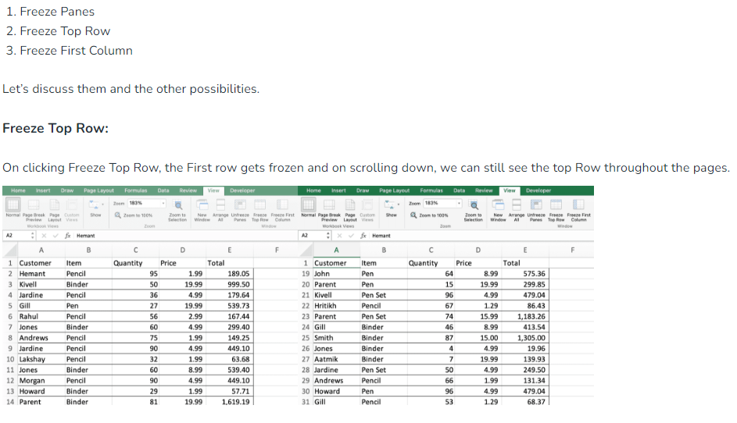

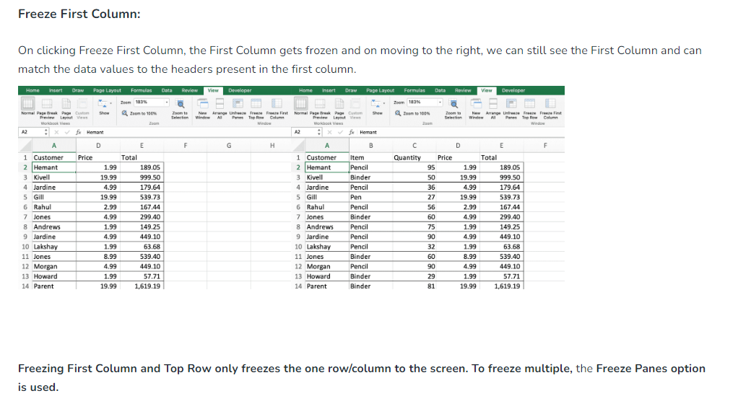

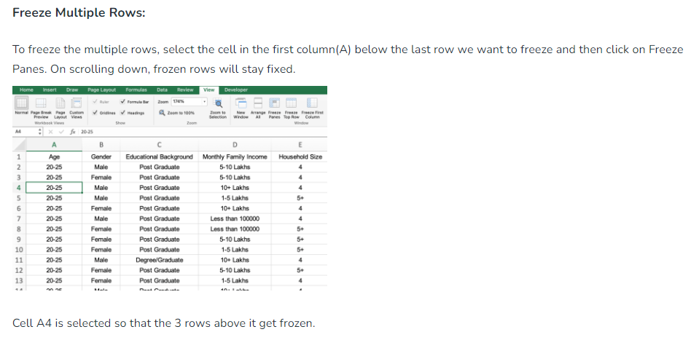

1. What are the different features available within the Freeze Panes command?

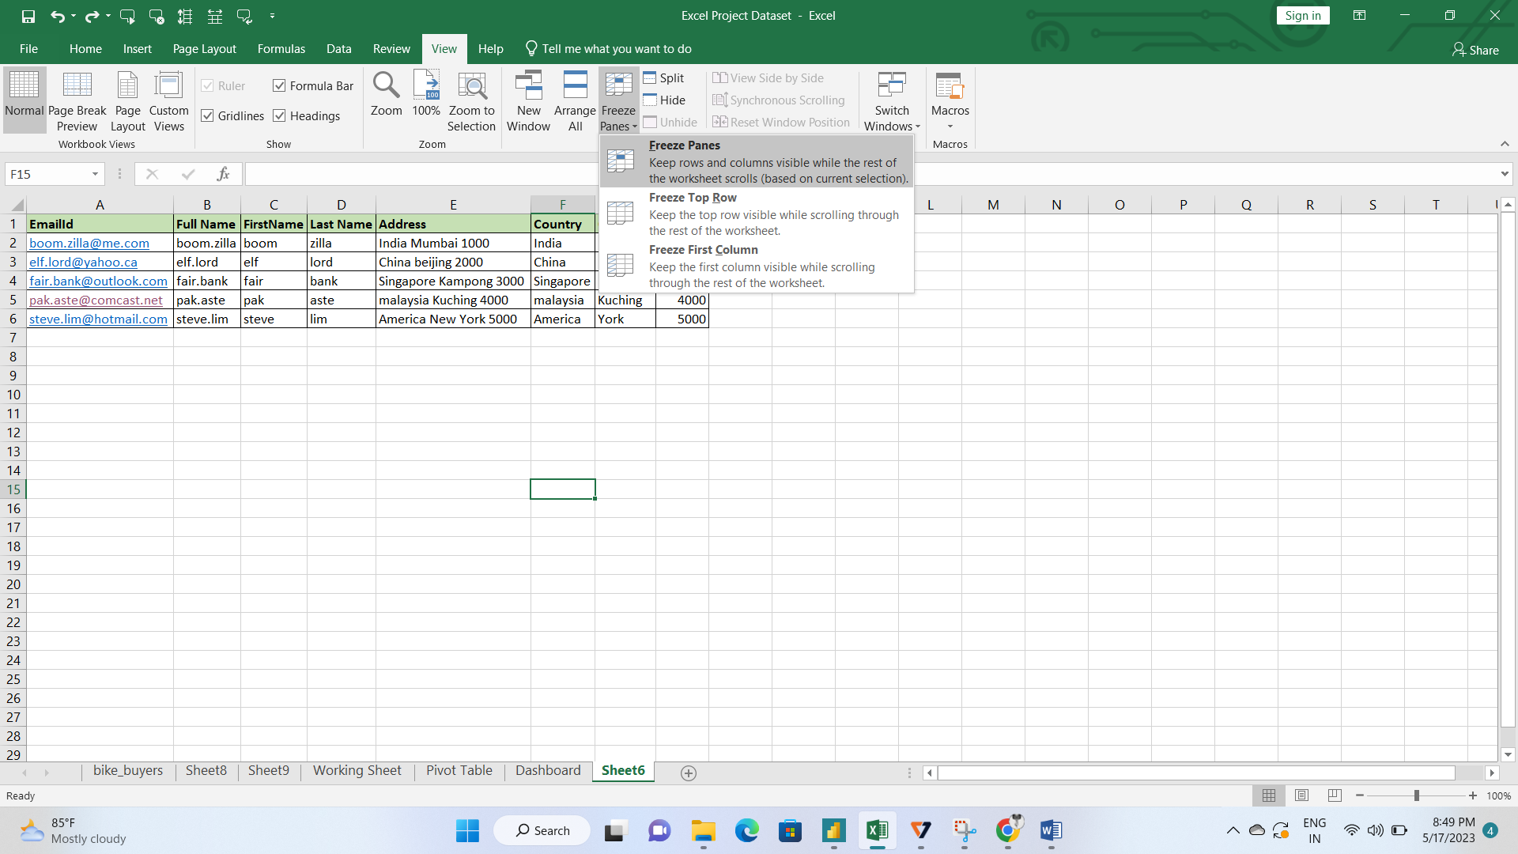

1. Explain what the different sheet options present in excel are and what they do?

It allows us to organize vast amounts of data across multiple sheets. Every Excel workbook has at least one sheet. By default, when we create a new Excel file, it usually has three sheets, namely Sheet1, Sheet2, and Sheet3. Furthermore, we can add or delete the desired number of sheets accordingly.